BACKGROUND
Founded in 2004 out of the San Francisco Department of Public Health, Project Homeless Connect (PHC) is a nationally recognized model aimed at serving people experiencing homelessness with dignity and respect. Many of the services provided are generally difficult to access, but are provided without limit at the event. The event has been successful due to the participation of government organizations, corporate partners, non-profit agencies, philanthropic groups and volunteers. San Francisco has leveraged enough community support to launch PHC into an Everyday Connect, in which the homeless may seek resources daily. Over the last several years, cities and communities across the nation, including Milwaukee, have taken on the PHC model and made it their own.
MILWAUKEE’S PROJECT HOMELESS CONNECT
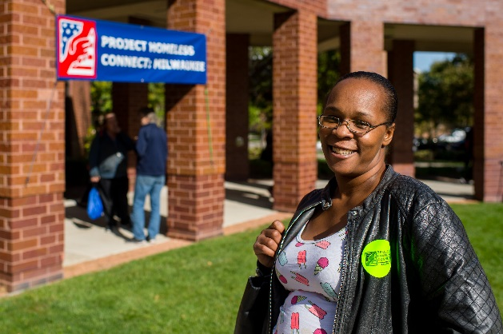
In the City of Milwaukee, about 900 people experience homelessness every day. Approximately 1 in 4 people live in poverty in Milwaukee, making it difficult to attain and hold stable housing. Research shows that people experiencing homelessness have higher rates of acute and chronic illness. Further, children who experience homelessness are more likely to struggle with learning and developmental disabilities.
Milwaukee’s Project Homeless Connect is a “one day, one-stop shop” event aimed at bringing multiple resources and services under one roof to better serve people experiencing homelessness.
Each year, the PHC Steering Committee strives to capture how the community has come together to invest in our city’s homeless population through time, service and other in-kind donation. Marquette University hosted the 8th Project Homeless Connect in 2017 and has been the host site for the last seven years. This year, the community provided over $33,000 in donated services and items. The event grows larger each year, inviting more volunteers and serving more and more community members. Preliminary numbers show that 477 guests were served by 475 volunteers. This is an increase of 99 guests from 2016.
SERVICE PROVIDERS & RESOURCES
About 80 organizations signed up to provide resources and services at the 2017 PHC. Resources and services included: dental screenings and tooth extractions, eye exams, haircuts, free lunches, legal consultation, birth certificate applications, and much more. Cold weather items such as hats, gloves and thermal socks were provided for each guest. The Marcus Corporation generously donated $3,000 worth of hygiene items from their hotels. A more robust and streamlined housing assessment area and employment resources area were created. Over $33,000 of products and services were donated for this year’s event. An estimate in the value of services and products is provided:
“Great event. Participants treated with great respect and dignity.”

Services/Resources |  | Products
Front Room Photography | $ 2,000 | Thermal socks | $884
Legal Aid | $550 | Winter coats | $13,500
Dental Screenings (89) | $1,750 | Hygiene Items | $3,703
Vision Screenings (88) | $4,400 | Venue & Equipment | $5,590
Birth Certificate Applications | $20 | Breakfast | $1,019
HIV testing | $20
*does not include all donations
Total of services & products |  |  | $ 33,436

VOLUNTEER ENGAGEMENT
Each year, Project Homeless Connect mobilizes community members from across Milwaukee and Southeast Wisconsin. This year, dedicated individuals traveled over 1.5 hours to volunteer for the event. A total of 475 volunteers served guests in 2017. An astonishing 2,356.5 hours of service were logged for a value of $56,885.
“This was the best volunteering experience I’ve ever had.”
THE GUEST EXPERIENCE
The most critical piece of the event is the experience of the guests served. Each volunteer is oriented to meet the needs of each guest, but above all, the purpose of the event is to ensure guests are treated with dignity and respect. In 2017, 430 guests completed guest exit surveys. Survey results were overwhelming positive and many guest reported satisfaction with their individual volunteer hosts. Additionally, the majority of guests reported they hoped to return to the event as volunteers in the future and found “everything” about the event to be very helpful.
“Thank you for all of the help.”
“I felt very helped and treated with respect.”

